Downtown Security Network (DSN)

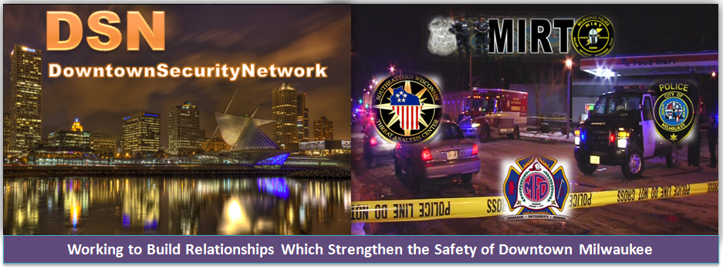

Thank you for expressing an interest in joining the Downtown Security Network (DSN).
Please review the guidelines for our organization and provide the information requested below.
Please forward your completed application to: James.Pleva@aus.com

Our steering committee will quickly process your response upon receipt and forward you the information for our next monthly meeting.

DSN Steering Committee

DSN Steering Committee
Courtney Morris (CMorris@Hempelcompanies.com)
VP of Development, Hempel Companies

David Metz (David.metz@viventhealth.org)
Director of Security Vivent Health

Robert Thiel (rthiel@milwaukee.gov)
Captain, 1st District
Milwaukee Police Department

Aaron Lipski (alipsk@milwaukee.gov) Chief, Support Bureau
Milwaukee Fire Department

James Pleva (James.pleva@AUS.com)
Security Account Manager
100 East Wisconsin Ave

DOWNTOWN SECURITY NETWORK PURPOSE STATEMENT

The Downtown Security Network (DSN) is an informal organization comprised of security professionals and public law enforcement representatives who provide security and safety services to the greater downtown Milwaukee area. The group’s purpose is to discuss and share information regarding security, safety, crime trends, and major events impacting downtown, emergency preparedness, and disaster recovery programs.

As a member in this organization, I understand…

- That the purpose of the meetings and this organization is to share security and public safety information with our members.

- That my membership to this organization is important to the good of the organization and the safety of Downtown Milwaukee, and therefore I agree to share such issues with the members of this organization.

- That information shared during these meetings is confidential, will only be shared with the appropriate people in my organization/business as it pertains to providing a safe environment.

- That information shared during meetings will be provided to those officers in my facilities that will benefit from it, while maintaining the confidentiality of this information.

- That membership is predicated on active communication and participation. My participation is for the greater good and not for the advancement of my business’ or organization’s marketing aims. In addition, any collection of information for the previously mentioned item shall initiate loss of membership.

Accepting the guidelines stated above, I would like an opportunity to become a member of the DSN and will provide the following information.

DOWNTOWN BUSINESS SECURITY CONTACT INFORMATION & APPLICATION FORM

Name of Downtown Facility/Building:
Address:
Last Name:
First Name:
Title:
Business Telephone: |  | ( )
Mobile Telephone: |  | ( )
E-mail Address:
Security Related Job Responsibilities (select all that apply)
 | Security Firm ___________________________ |  | Law Enforcement _______________________
 | Facility/Grounds/Personnel Security |  | Gov’t _________________________________
 | Facility/Grounds Maintenance |  | Realty Firm ____________________________
 | Fire/Medical ____________________________ |  | Corporate Investigator
 | Emergency Response |  | Other:_________________________________
Approximate # of Tenants in Facility:
24 Hour Emergency Phone Number for Your Facility: |  | ( )

