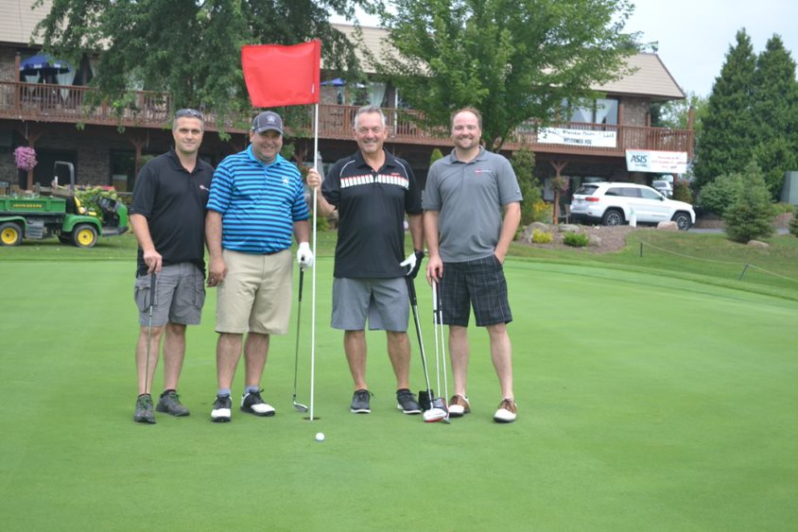

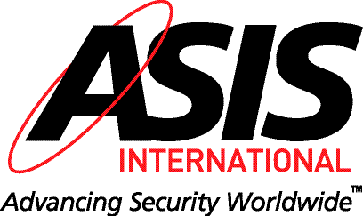

Greater Milwaukee Chapter
Annual Golf Event
Friday, August 12, 2022
Muskego Lakes Country Club
14020 Loomis Road • Muskego, WI 53150
Shotgun Start at 8:00am (Registration starts at 7:15)
Four Person Best Ball Format
Support Your ASIS Chapter and all of our Educational and Charitable work

Entry Fee: $135.00/per person or
$485.00/foursome

Checks, Cash, or Credit Cards accepted

Includes 18 holes with Cart and Dinner following golf. Door Prizes, Prizes for Top Teams, 50/50 Raffle & Other GREAT prizes
For Golf Outing Registration: Click HERE or go to
Milwaukee ASIS 2022 Golf Outing

For Questions contact Chris Magnus: Phone: 773-709-0130 Email: golfouting@asis-mil.org

Special Pricing available for 1st year golfers and Young Professionals $90.00

Note: All checks must be received prior to August 6, 2022. ASIS Milwaukee Chapter – P.O. Box 26722, Milwaukee, WI 53226
Sponsorship Opportunities
Dinner Sponsor $450
Refreshment Cart Sponsor $400
Hole Sponsor $150
Prize Sponsor $150
Trophy Sponsor $150
19th Hole - Sponsor $200
For Sponsorship Options: Click HERE
Do you want to network and join us for dinner only? Dinner is $50 per person
We are having a Pig Roast this year!
SINGLE ENTRY: Golfer Business Email Phone___________________________
FOURSOME: Golfer #1 Business Email Phone___________________________
Golfer #2 Business Email Phone___________________________
Golfer #3 Business Email Phone___________________________
Golfer #4 Business Email Phone___________________________
DINNER ONLY: Name Business Email Phone__________________________

